

**School of Computer Science and Engineering**

**J Component report**

**Title: Fetal Health Classification**

**Team Members: Rathakrishnan R K**

**Nandhini M**

**Anantharaman J**

**Beulah S**

**Abstract**

Human unborn baby health is monitored by electronic Fetal monitoring equipment which generates cardiotocographic data. This cardiotocographic data consists of fetal heart rate (FHR), uterus contractions rate, etc. The inference achieved from analysing the cardiotocographic data lets us know whether the foetus is normal, suspect or pathologic with immediate action needed. It is very important and critical to making this inference quickly as any delay could be a risk to both fetal and mother. This article gives the development of machine learning-based decision tree algorithm that will classify any given foetus health into normal, suspect and pathologic based on the given cardiotocographic data.

In this article, a dataset consisting of 2126 observations with 22 attributes or readings is considered and 90% of this data is used for training the decision tree model and the rest 10% is used to test the accuracy of the developed model.

**Introduction**

Reduction of child mortality is reflected in several of the United Nations Sustainable Development Goals and is a key indicator of human progress. The UN expects that by 2030, countries end preventable deaths of newborns and children under 5 years of age, with all countries aiming to reduce under‑5 mortality to at least as low as 25 per 1,000 live births. Parallel to notion of child mortality is of course maternal mortality, which accounts for 295 000 deaths during and following pregnancy and childbirth (as of 2017). The vast majority of these deaths (94%) occurred in low-resource settings, and most could have been prevented.

In light of what was mentioned above, Cardiotocography (CTGs) are a simple and cost accessible option to assess fetal health, allowing healthcare professionals to take action in order to prevent child and maternal mortality. The equipment itself works by sending ultrasound pulses and reading its response, thus shedding light on fetal heart rate (FHR), Cardiotocography (CTG) is the most widely used in the clinical routine evaluation of the main approach to detect fetal state. In this paper, twelve machine learning single models have firstly experimented on CTG dataset. Secondly, the soft voting integration method is used to integrate the four best models to build the Blender Model, and compared with the stacking integration method. Compared with the traditional machine learning models, the model proposed in this paper performed excellently in various Classification Model evaluations, with an accuracy rate of 0.959, an AUC of 0.988, a recall rate of 0.916, a precision rate of 0.959, a F1 of 0.958 and a MCC of 0.886.

**Dataset description**

The UCI CTG dataset is the source of information required for the analysis and development of fetal health predictive model. CTG information provides a visualized un healthiness of the foetus that helps for early intervention before the risk happening. It consists of 2126 instances with 22 chosen attributes which are multivariate datatypes. To do the analysis attributes of the foetus, such as FHR and maternal related UC are required. Most of the attributes are numerical (the combination of discrete and continuous data). The Attributes from 1to 9 are discrete and 10 to 20 are continuous whereas 21to 22 are nominal variable.

The dataset has been classified by expert obstetrician into 3 classes:

* Normal
* Suspect
* Pathological

**Features**

* Baseline value-FHR baseline (beats per minute)
* Number of accelerations per second
* Number of Fetal movements per second
* Number of uterine contractions per second
* Number of light decelerations per second
* Number of severe decelerations per second
* Number of prolonged decelerations per second
* Percentage of time with abnormal short term variability
* Mean value of short term variability
* of time with abnormal long term variability
* Mean value of long term variability
* Width of FHR histogram
* Minimum (low frequency) of FHR histogram
* Maximum (high frequency) of FHR histogram
* Number of histogram peaks
* Number of histogram zeros
* Histogram mode
* Histogram mean
* Histogram median
* Histogram variance
* Histogram tendency
* Target

**Literature review**

Despite evidence demonstrating no neonatal benefit, the medicolegal climate in the United States requires obstetricians to integrate continuous intrapartum surveillance into their care of the pregnant labor-patient. The intent of this article is to familiarize the reader with the standardized, quantitative nomenclature recommended to describe intrapartum cardiotocography in order to reduce miscommunication among providers caring for the labor patient [1].

Cardiotocography (sometimes known as electronic fetal monitoring), records changes in the fetal heart rate and their temporal relationship to uterine contractions. The aim is to identify babies who may be short of oxygen (hypoxic), so additional assessments of fetal well-being may be used, or the baby delivered by caesarean section or instrumental vaginal birth.

Continuous cardiotocography during labour is associated with a reduction in neonatal seizures, but no significant differences in cerebral palsy, infant mortality or other standard measures of neonatal well-being. However, continuous cardiotocography was associated with an increase in caesarean sections and instrumental vaginal births. The real challenge is how best to convey this uncertainty to women to enable them to make an informed choice without compromising the normality of labour [2].

In April 2008, the Eunice Kennedy Shriver National Institute of Child Health and Human Development, the American College of Obstetricians and Gynecologists, and the Society for Maternal-Fetal Medicine partnered to sponsor a 2-day workshop to revisit nomenclature, interpretation, and research recommendations for intrapartum electronic fetal heart rate monitoring. Participants included obstetric experts and representatives from relevant stakeholder groups and organizations. This article provides a summary of the discussions at the workshop. This includes a discussion of terminology and nomenclature for the description of fetal heart tracings and uterine contractions for use in clinical practice and research. A three-tier system for fetal heart rate tracing interpretation is also described. Lastly, prioritized topics for future research are provided [3].

Computer-aided fetal monitoring is based on automated analysis of the fetal heart rate (FHR) variability. The first and the main step in the automated signal interpretation is the estimation called FHR baseline. There are various algorithms for baseline estimation, of different efficiency. For its evaluation, the method of modeling of FHR signal based on the preset baseline component has been developed. The best algorithm is expected to provide the same baseline as the component baseline used to model the FHR signal. Generated signals were used to compare the baselines that have been estimated by two algorithms: the first one relying on artificial neural networks and the classical one using nonlinear filtering of FHR signal [4].

In this study, a new scheme was presented for the prediction of fetal state from fetal heart rate (FHR) and the uterine contraction (UC) signals obtained from Cardiotocography (CTG) recordings. CTG recordings are widely used in pregnancy and provide very valuable information regarding fetal well-being. The information effectively extracted from these recordings can be used to predict pathological state of the foetus and makes an early intervention possible before there is an irreversible damage to the foetus. The proposed scheme is based on adaptive neuro-fuzzy inference systems (ANFIS). Using features extracted from the FHR and UC signals, an ANFIS was trained to predict the normal and the pathological state. The method was tested with clinical data that consist of 1,831 CTG recordings. Out of these 1,831 recordings, 1,655 of them were classified as normal and the remaining 176 were classified as pathological by a consensus of three expert obstetricians. It was demonstrated that the ANFIS-based method was able to classify the normal and the pathologic states with 97.2 and 96.6 % accuracy, respectively [5].

**Methods to use**

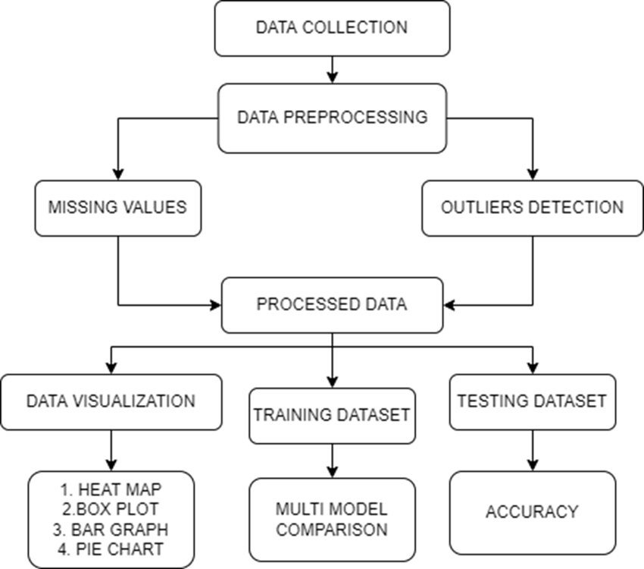

**FETAL HEALTH CONDITIONS**

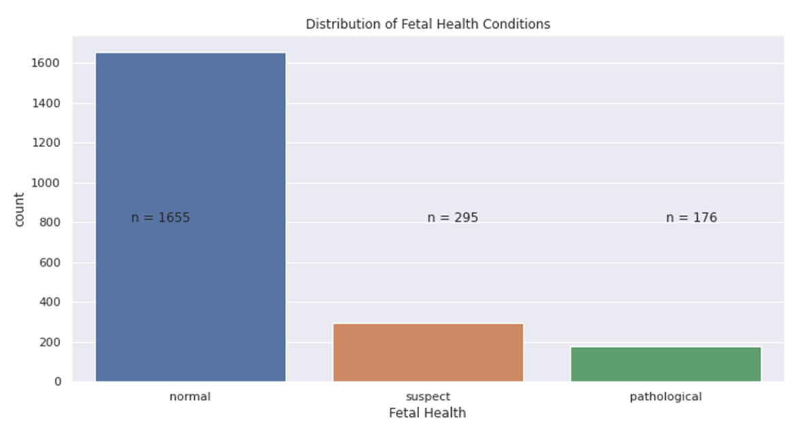

The distribution of the target variable is like real world; not all births are unhealthy or resulted with death of the new born. According to world bank data, the mortality rate in 2019 28.2 per 1000 births. So we could expect a distribution like this one. However due to machine learning purposes, this is not good. I will work on this after finishing EDA.

**ACCELERATIONS**

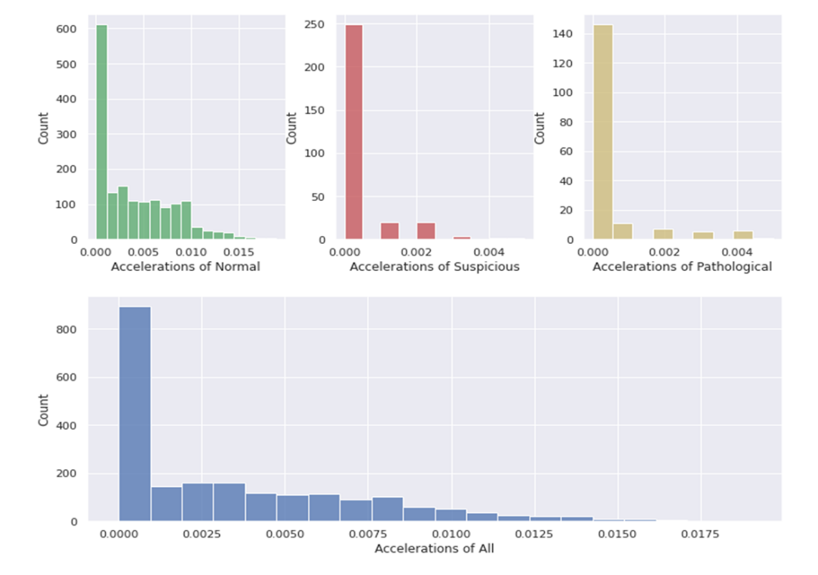

Most of the data were gathered around 0. However, values above 0.005 is only on Normal cardiograms.

**PROLONGED DECELERATIONS**

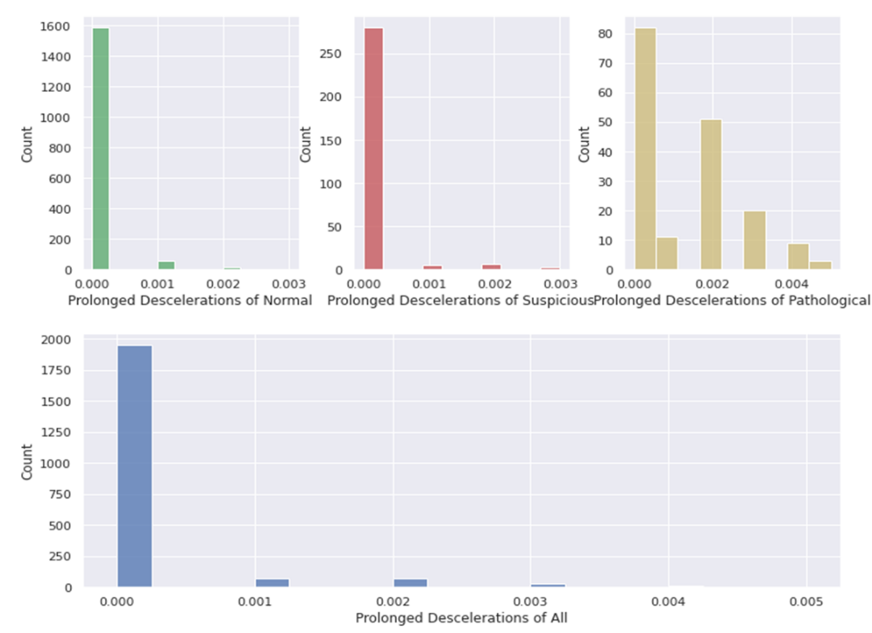

Again most of the data is at 0, however the amount of 0.001's and higher increasing in suspicious and pathologicals.

**ABNORMAL SHORTTERM VARIABILITY**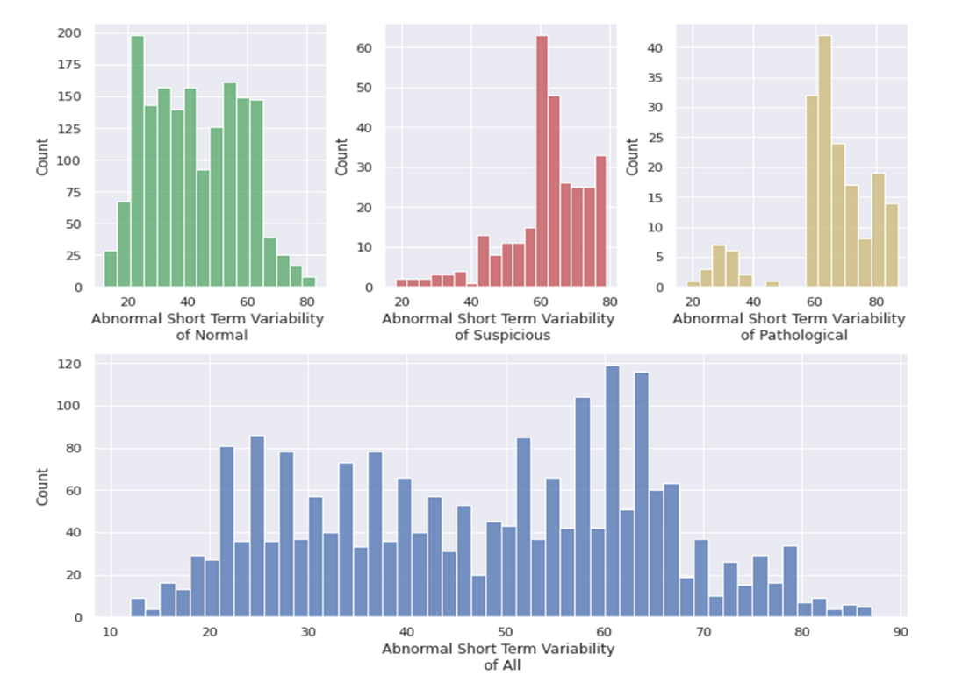

Normal values are gathered between 20-60; and the amount of variability of suspicious and pathologicals are gathered above 60's.

**ABNORMAL LONGTERM VARIABILITY**

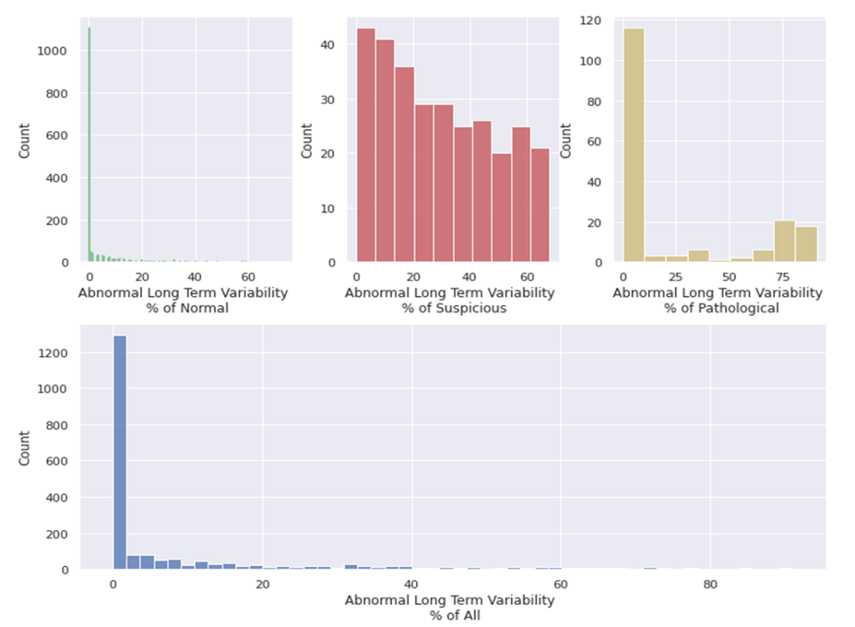.

Most of the normals are gathered at 0. Suspicious babies' values are gathered between 0 to 70, pathological babies gathered above 75 if not in 0.

**Classification**

Classification is one of the supervised data mining techniques that employ a pre-classified dataset to develop a predictive model and perform diagnosis. Classification is a necessary supervised learning task used to predict an unborn baby health state from CTG dataset. Most of the data mining algorithms that have been developed for data classification in medical diagnosis are CatBoost (CatBoost), Light Gradient Boosting (lightgbm), Gradient Boosting (GBC), random Forest (RF), Extra Trees (et), decision tree (DT), K-nearest neighbour (KNN), Adaboost(ADA), Logistic Regression(LR), Linear Discriminant Analysis(LDA), Ridge Classifier (ridge), SVM – Linear Kernel (SVM), Dummy Classifier(dummy), Naive Bayes(NB), Quadratic Discriminant Analysis(QDA).

**MODELS USED**

**Extra trees**

Extra Trees is an ensemble machine learning algorithm that combines the predictions from many decision trees. It is related to the widely used random forest algorithm. It can often achieve as-good or better performance than the random forest algorithm, although it uses a simpler algorithm to construct the decision trees used as members of the ensemble. It is also easy to use given that it has few key hyperparameters and sensible heuristics for configuring these hyperparameters.

**CatBoost**

A one-dimensional array of categorical columns indices (specified as integers) or names (specified as strings). This array can contain both indices and names for different elements. If any features in the cat features parameter are specified as names instead of indices, feature names must be provided for the training dataset. Therefore, the type of the X parameter in the future calls of the fit function must be either CatBoost. Pool with defined feature names data or pandas. Dataframe with defined column names. Return the number of trees in the model. This number can differ from the value specified in the --iterations training parameter in the following cases:

* The training is stopped by the overfitting detector.
* The use-best-model training parameter is set to True

**Random Forest algorithm (RF)**

RF algorithm was a particular synthesis of classification accuracy and give chance to succeed besides optimal generalizations based on bagging methods.

Some of considerable features of RF are:

* Giving the chance of reliability classification any techniques
* Allow to examine necessity of the classifiers and
* Examine Trained classifier that allows to identify correlations among selected data’s

**K-Nearest Neighbour algorithm (KNN)**

KNN is an algorithm which is based on distance between items. KNN was the parameter free method which uses a Euclidean distance measure. This algorithm expressed in terms of the resemblance measure among the pair of data in N-dimension, the number of nearest data that are trained for classification, and vector of training data applied by the classifiers.

**Support Vector Machine**

SVM is a popular classier that performs classification tasks by constructing hyperplanes in a multidimensional space that separates cases of different class labels. Both regression and classification tasks are supported by SVM that consists multiple numerical variables. Nonlinear kernel functions help in order to integrate data into a suitable form that tends to split the data [16]. Due to a better generalization capability and low computational cost, RBF kernel has been applied in this work for separating the optimal hyperplane.

**Light gradient boosting machine**

Light GBM is a gradient boosting framework based on decision trees to increases the efficiency of the model and reduces memory usage. It uses two novel techniques: Gradient-based One Side Sampling and Exclusive Feature Bundling (EFB) which full fills the limitations of histogram-based algorithm that is primarily used in all GBDT (Gradient Boosting Decision Tree) frameworks. The two techniques of GOSS and EFB described below form the characteristics of Light GBM Algorithm. They comprise together to make the model work efficiently and provide it a cutting edge over other GBDT frameworks

**Gradient-based One Side Sampling Technique for Light GBM:**

Different data instances have varied roles in the computation of information gain. The instances with larger gradients(i.e., under-trained instances) will contribute more to the information gain. GOSS keeps those instances with large gradients (e.g., larger than a predefined threshold, or among the top percentiles), and only randomly drop those instances with small gradients to retain the accuracy of information gain estimation. This treatment can lead to a more accurate gain estimation than uniformly random sampling, with the same target sampling rate, especially when the value of information gain has a large range.

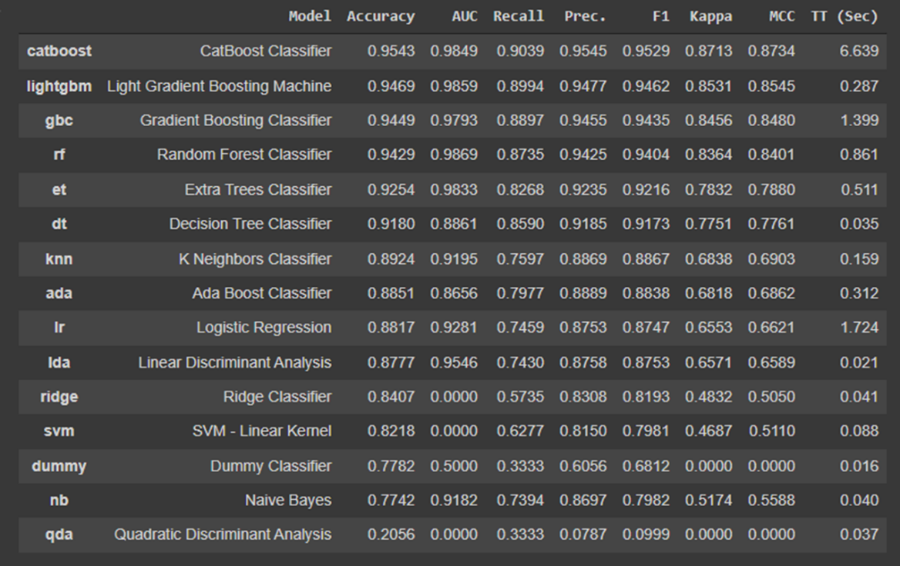

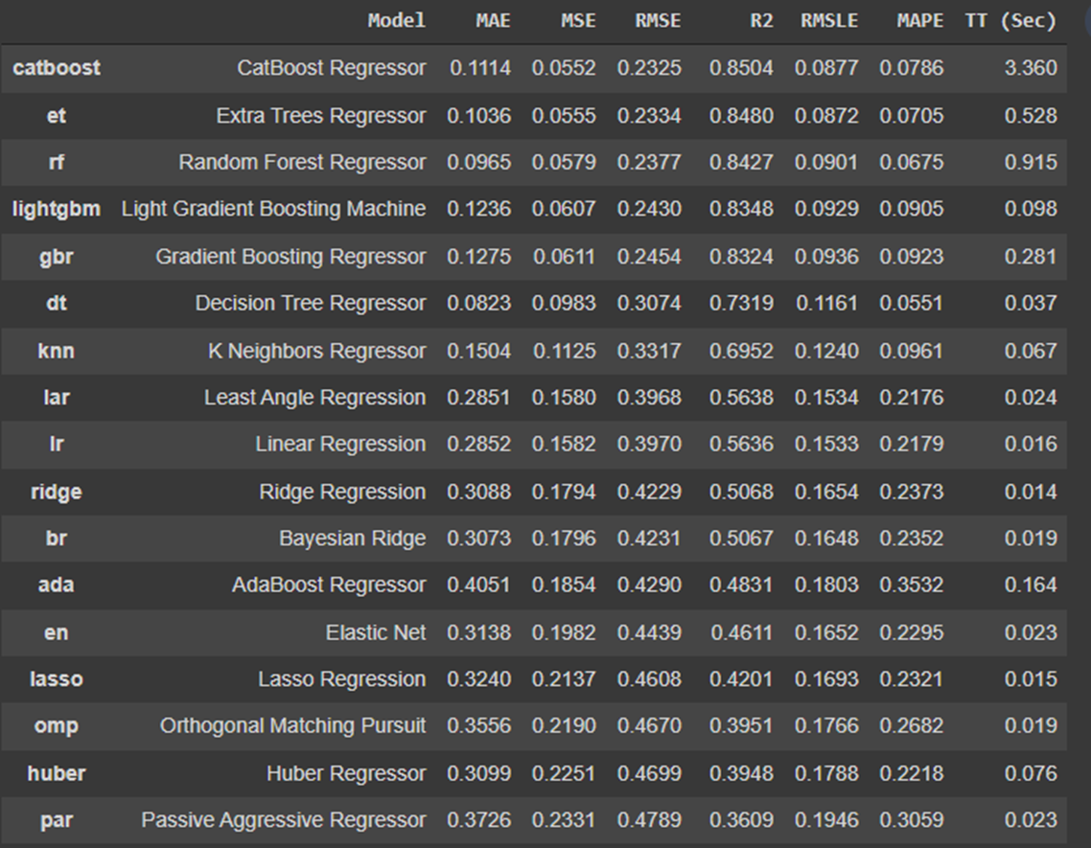

**Conclusion:**

The Cardiotocography data of 2126 pregnant women were classified into the normal, suspect, or pathologic state by obstetrician. The Cardiotocography data comprised of 77.85% normal, 13.88% suspect and 8.28% pathological state. The training data, the top 5 classification models generated by CatBoost , LightGbm, Gradient boosting, Random forest had higher precision of >94% to predict the fetal health based on the CTS tracings. The classification model developed using CatBoost model had the highest prediction accuracy for an adverse fetal outcome.

**REFERENCES**

1.Robinson, B.: A review of nichd standardized nomenclature for cardiotocography: the importance of speaking a common language when describing electronic fetal monitoring. Reviews in Obstetrics and Gynecology 1(2), 56 (2008)

2.Alfirevic, Z., Devane, D., Gyte, G.M., et al.: Continuous cardiotocography (ctg) as a form of electronic fetal monitoring (efm) for fetal assessment during labour. Cochrane Database Syst. Rev. 3 (2006)

3.Macones, G.A., Hankins, G.D., Spong, C.Y., Hauth, J., Moore, T.: The 2008 national institute of child health and human development workshop report on electronic fetal monitoring: update on definitions, interpretation, and research guidelines. Journal of Obstetric, Gynecologic, & Neonatal Nursing 37(5), 510–515 (2008)

4.Kupka, T., Wrobel, J., Jezewski, J., Gacek, A.: Evaluation of fetal heart rate baseline estimation method using testing signals based on a statistical model. In: 28th Annual International Conference of the IEEE Engineering in Medicine and Biology Society, EMBS 2006, August 30-September 3, pp. 3728–3731 (2006)

5.Ocak, H., Ertunc, H.: Prediction of fetal state from the Cardiotocography recordings using adaptive neuro-fuzzy inference systems. Neural Computing and Applications, 1–7 (2012)

6. Mei-Ling Huang and Yung-Yan Hsu, Fetal distress prediction using discriminant analysis decision tree and artificial neural network, vol. 5, no. 9, pp. 526-533, 2012.

7. Hasan Ocak and Huseyin Metin Ertunc, Prediction of fetal state from the Cardiotocography recordings using adaptive neuro-fuzzy inference systems, vol. 23, no. 6, pp. 1583-1589, 2013.

8. S. Shah, W. Aziz, M. Arif and M. Nadeem, "Decision Trees Based Classification of Cardiotocography Using Bagging Approach", 2015 13th International Conference on Frontiers of Information Technology (FIT), pp. 12-17, 2015.

9. J. Piri, P. Mohapatra and R. Dey, "Fetal Health Status Classification Using MOGA - CD Based Feature Selection Approach", 2020 IEEE International Conference on Electronics Computing and Communication Technologies (CONECCT), pp. 1-6, 2020.

10. Fei et al., "Automatic Classification of Antepartum Cardiotocography Using Fuzzy Clustering and Adaptive Neuro -Fuzzy Inference System", 2020 IEEE International Conference on Bioinformatics and Biomedicine (BIBM), pp. 1938-1942, 2020.